IDEAL COLLEGE OF ARTS AND SCIENCES (A)
(A.P. Govt., Aided., Autonomous & NAAC B++)
Dr. P.V.N. RAJU VIDYAPRANGANAM
Samalkot Road, KAKINADA
East Godavari Dist
Andhra Pradesh

Department of ECONOMICS

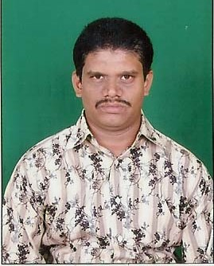

PROFILE

- Name : D.V.S. Viswanadha Raju
M.A.,
- Designation : Lecturer in ECONOMICS
Ideal College of Arts & Sciences (A)
Kakinada-533003
A.P., INDIA.
- Date of Birth : 15.07.1976
- Nationality : Indian
- Mobile no : 9849160777
- E-mail : dvsvraju@gmail.com
- Address for Correspondence : DVS Viswanadha Raju
Lecturer in Economics
Ideal College of Arts & Sciences,
Kakinada – 533 003, A.P., India.

- Details of Educational Qualifications:
Sl. No. | Course | University | Year | Specialization
1 | M.A | DNR College, PG Courses (Affiliated to Andhra University, Visakhapatnam) | 1998 | Economics

- Experience:

Sl.No | Designation | College | Date of Joining | Experience
1 | Lecturer | SDVRR Degree College, Kolanka | 1998 to 2005 | 7 Years
2 | Lecturer | Ideal College of Arts & Sciences, Kakinada | 2005 to till the date | 12 years

- Regional/ State/National level Conferences/Workshops/Seminars
  - Workshops-3
  - Seminars-2

- Administrative Experience:
Member, Board of Studies,

- Training Programs/ Courses attended:
Three days Training Programme on Ethics and Values conducted by Govt., Arts College, Rajahmundry.

